

***A Mini Project Synopsis on***

## Online Voting System

##### S.E. - I.T Engineering

**Submitted By**

|  |  |
| --- | --- |
| **Suyash Jadhav** | **20104136** |
| **Karan Maurya** | **20104070** |
| **Ashish Mundhada** | **20104107** |
| **Pratham Lotankar** | **20104025** |

**Under The Guidance Of Prof. Charul Singh**

**DEPARTMENT OF INFORMATION TECHNOLOGY**

A.P.SHAH INSTITUTE OF TECHNOLOGY

G.B. Road, Kasarvadavali, Thane (W), Mumbai-400615 UNIVERSITY OF MUMBAI

**Academic year : 2021-22**

# CERTIFICATE

This to certify that the Mini Project report on **Online Voting System**has been submitted

Karan Maurya (20104070), **Suyash Jadhav(20104136), Ashish Mundhad (20104107), Pratham Lotankar(20104025)** who are a Bonafede students of A. P. Shah Institute of Technology, Thane, Mumbai, as a partial fulfilment of the requirement for the degree in **Information Technology**, during the academic year **2021-2022** in the satisfactory manner as per the curriculum laid down by University of Mumbai.

Guide

**Prof. Charul Singh**

Prof. Kiran Deshpande Dr. Uttam D.Kolekar

Head Department of Information Technology Principal

External Examiner(s) 1.

2.

Place: A.P Shah Institute of Technology, Thane Date:

# INDEX

1. Introduction..............................................................................................4

1.1 Purpose...................................................................................................4

1.2 Objectives...............................................................................................5

1.3 Scope......................................................................................................6

2. Problem Definition....................................................................................7

2.1 User Problem Statement………………………………………………...7

3. Proposed System………………………………………………………....8

3.1 Features and modules…………………………………………………...9

4. Project Outcomes......................................................................................10

5. Software Requirements.............................................................................10

6. Project Design...........................................................................................12

7. Project Scheduling……………………………………………………….13

8. Conclusion……………………………………………………………….14

References Acknowledgement

**Chapter 1**

### Introduction

At their core, online voting systems protect the integrity of your vote by preventing voters from being able to vote multiple times. As a digital platform, they eliminate the need to gather in-person, cast votes using paper, or by any other means (e.g. email, insecure survey software).

You may hear an online voting system being referred to as an online election system, an online e voting system, or electronic voting. These all make reference to the same thing: a secure voting tool that allows your group to collect input from your group and closely scrutinize the results in real time.

* An Online voting system is a software platform that allows groups to securely conduct polls and votes .
* This System will help save people’s time by voting online rather than going to the physical polling station.
* our system will give access to admin to Create polls of any subject and user will choose their option.
* This application will conduct a series of questions along with many choices.
* This application will show no.of votes gone to which particular subject.

###### Voting on something, or a set of things

This includes, for example, voting on:

* Rules & regulations (e.g. bylaws, policy decisions)
* Selections (e.g. award show nomination)
* Employee preferences (e.g. workplace scheduling)

### .

#### Purpose:

#### This paper describes an online voting system that was designed to meet the electoral needs of universities and colleges. Design/Methodology: The prototyping model was adopted as the methodology for designing the application. In designing the Online Voting System, Flowcharts, Use Case Diagrams and Data Flow Diagrams (DFD) were also employed. Results: The system generated a more convenient voter and candidate registration interface, an efficient voting interface, vote storage and count plus immediate result compilation etc. Outputs from the application include a page showing a list of all the registered voters, a list of all qualified candidates, and the results of the total vote count for each candidate in the Faculty of Science. A functionality test was also carried out on the developed system where 20 registered students appraised the system by filling out an electronic questionnaire. Originality: Several e-voting systems have been developed for varying uses. This system however was specifically developed for use in tertiary institutions and had security capabilities inbuilt into its design. This originality though peculiar to the adopted case study can be used for developing other kinds of applications. The system was also designed for faculty level voting but can be easily adapted for smaller or larger scenarios. Practical Implications: It can be concluded that the Online Voting System incorporates all the features of a regular Voting system but offers an alternative method of conducting elections that is less stressful, easier and faster through the use of a network. It eliminates the moribund activities associated with the manual system and reduces drastically the duration of elections, thus, resulting in huge financial savings. It is thus recommended for use in any election if well adjusted. Keywords: Online Voting, Electronic Voting, Democracy, Voting System. Paper Type: Research Paper

Online voting tools and online election voting systems help you make important decisions by gathering the input of your group in a way that’s systematic and verifiable.

Oftentimes, these decisions are made on a yearly basis - during an event (e.g. your organization’s AGM) or at a particular time of the year. Or you might run ongoing polls amongst your group (e.g. anonymous employee feedback surveys).

#### Objectives:

* **Elect your leadership**: A board of directors election is a good example, where there are multiple positions (e.g. chair, vice president, secretary, treasurer). All of which may include supporting documentation (e.g. biographies, resumés, headshots).
* **Admit new members to your group**. This helps you stick to a regular, fair process of evaluation and lets candidates know what to expect.
* **Gather**[**anonymous**](https://www.eballot.com/anonymous-secret-voting-system)**feedback from your employees**. Managers (and managers of managers) want to know how their employees truly feel about their jobs and work life. Using an online voting system with a capacity for secret balloting helps employees express their true feelings, by understanding and trusting that their feedback will be heard, but not tied directly to them.
* **Vote on yearly budgets**. And since adjustments to your budget are often needed, an online voting system will keep voting secure and accessible - no matter where the members of your group may happen to be.
* **Alter your operational procedures and bylaws**. Just like leadership elections, expect group members to react strongly toward changes - no matter how minor - to organizational processes. You’ll want to collect individual responses to these changes in a systematic manner.
* In all of these cases, an online voting system will enable better decisions, justify those decisions, and let you share proof that these decisions were carried out in line with the standards of your group.
* This project will serve the following objectives:-
* Make an easy to use environment for Administrator and Voter.
* Add and maintain Voter details.
* Easy to register and login.
* Easy to cast their vote.
* Results will be displayed very fast.
* Allow admin to Create polls by inserting data with question of who they want to vote.
* Voter can cast their vote by choosing their choice answer

#### Scope:

## Increasing number of voters as individuals will find it easier and more convenient to vote.

## Less effort and less labor intensive, as the primary cost and focus primary on creating, managing, and running a secure web voting portal.

## The system can be used anytime and from anywhere by the Voters. iv. No one can cast votes on behalf of others and multiple times.

## Saves time and reduces human intervention.

## The system is flexible and secured to be used.

## Unique Identification of voter through Aadhar number.

## Improves voting with friendly Interface.

## No fraud vote can be submitted

## Chapter 2

### Problem Definition:

In the recent years there are many literature on online voting has been developed. While online voting has been an active area of research in the recent years, efforts to develop real-world solutions have just begun posing several new challenges. The use of insecure Internet, well documented cases of incorrect implementations and the resulting security Breaches have been reported recently. These challenges and concerns have to be resolved in order to create public trust in online voting..

### 2.1 User Problem Statement:

Online Voting System provides the online registration form for the users before voting and makes the users to cast their vote online. The system is to be developed with high security and user friendly

## Chapter 3

### Features and modules:

##### Features:

##### Customization : Admin can Create their own Questions and choices and can display result to the voter.

##### Easy Online voting : A voter can easily cast their vote to their following choice online rather than visiting polling station.

##### Security : It is secure way to vote, Because at every step voter has to Login and credentials has to be entered at every steps

### Cost Savings and Efficiency : The cost savings and efficiencies you’ll gain are unparalleled to any other method of voting. Groups switching to web-based online voting systems from more expensive and less efficient voting technologies like voting machines, paper ballots, and in-person meetings will reap these benefits without increasing risk.

### Voter Accessibility : Needing to fly halfway around the world to vote at your organization’s annual meeting is an example of a vote with low accessibility. On the other hand, tapping a link on your mobile device that securely logs you into the online voting system website is an example of a vote or election with high accessibility.

High accessibility generates greater turnout rates among your group.

**Modules used:**

* Pyttsx3: Basically, this module is used to convert text to speech in python. We can install this library using "pip install pyttsx3" command. The main advantage of this module is that it works offline.
* **matplotlib** is a collection of functions that make matplotlib work like MATLAB. Each pyplot function makes some change to a figure: e.g., creates a figure, creates a plotting area in a figure, plots some lines in a plotting area, decorates the plot with labels, etc.
* Wikipedia: This module is used to get the information from Wikipedia or to search something on Wikipedia. We can install this module using "pip install Wikipedia" command.
* Web browser: This is used to display web-based documents on the web browser. This module is built-in in python.
* Os: The OS module in Python provides functions for creating and removing a directory (folder), fetching its contents, changing and identifying the current directory, etc.
* Smtplib: SMTP (simple mail transfer protocol) is used to send an email or to route an email between servers. Python provides the smtplib module for this functionality. We can install this module using "pip install smtplib".

## Chapter 4

### Project Outcome:

### Admin can login.

### Voter can Login and Register.

### Admin have access to create polls.

### Voter can vote the Polls .

### Admin and Voter can see results of the poll after voting.

### Voter can see the graph of how many percent vote each one of the subject.

**Chapter 5**

**Software used:**

Language: Python

IDE: Pycharm

## Chapter 6

### Project Design:

1. Home Page :

* In this Online Voting we can do Registration .
* We can see Election Results
* In system Member can Become an Election Worker
* Direct go for the voting

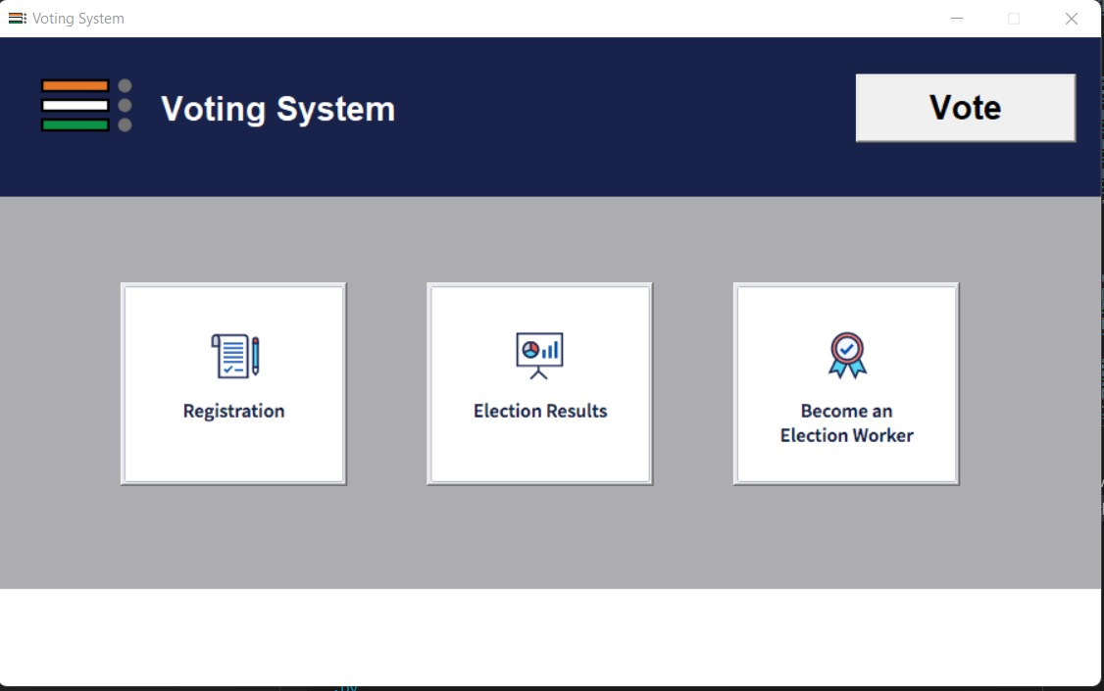

1. Registration Become a member .

* Here Member Can Regisrtration by create a username and passwords.
* Here Password Confirm Done By the User.
* User Become A Election member.

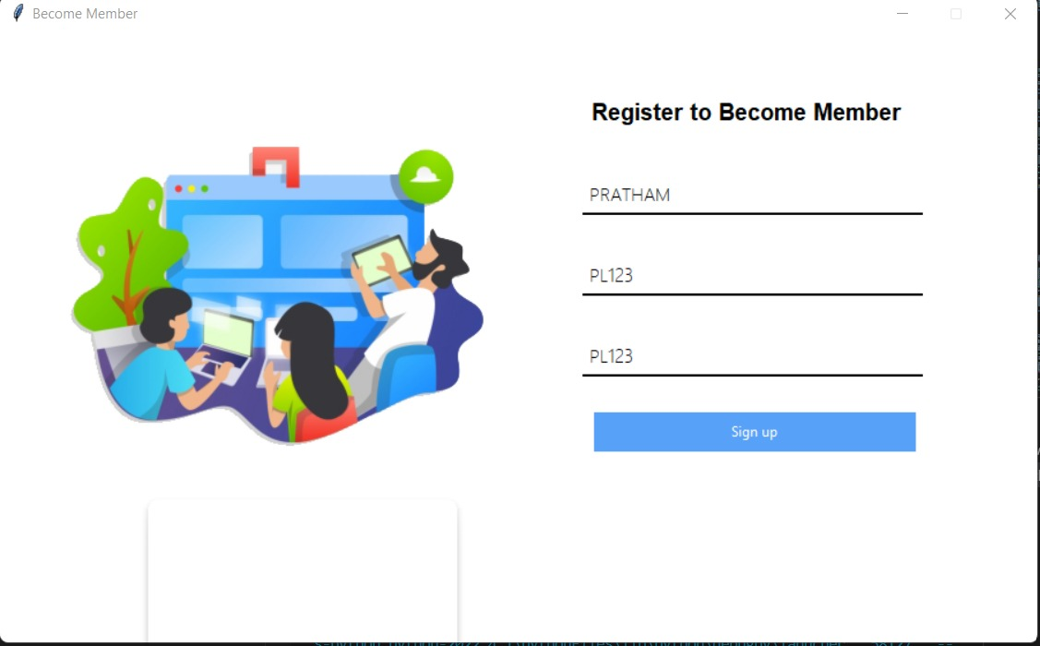

1. Login For Voting

* Here user can login for voting
* By confirming username and password.

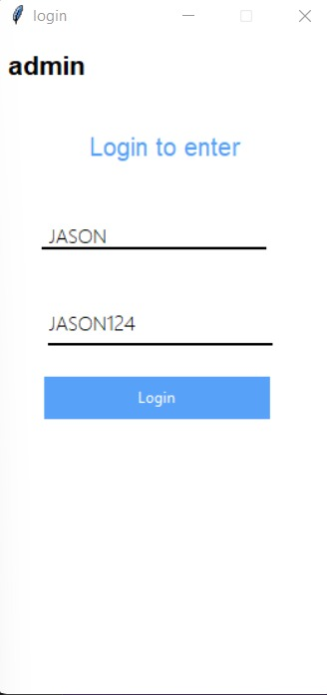

1. Vote

* Here use can choice your for voting as number voting are present here for vote .
* 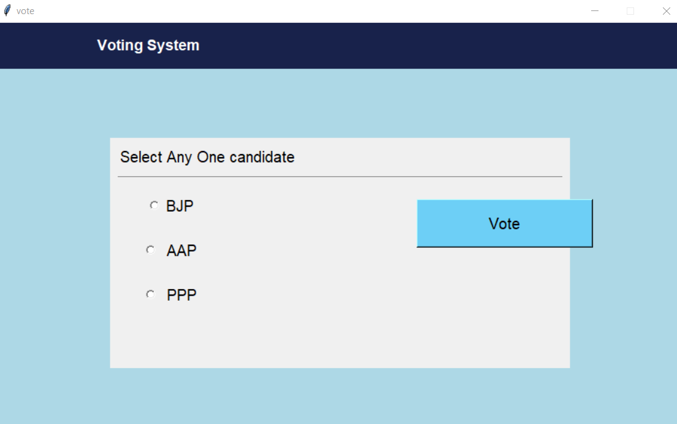

1. Result

* Here show No voting
* Pie chart were display

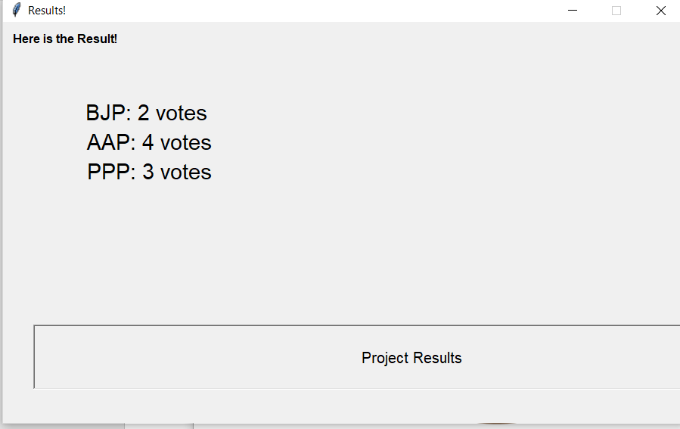

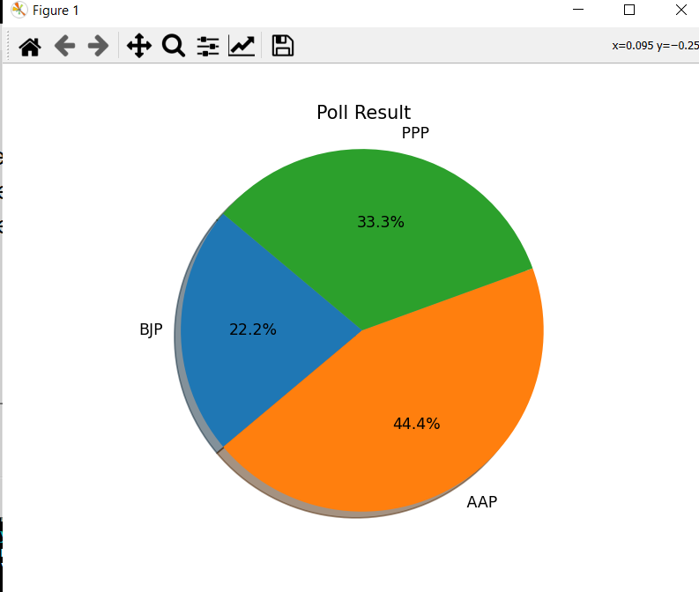

|  |  |  |  |
| --- | --- | --- | --- |
| **Sr. No** | **Group Member** | **Time duration** | **Work to be done** |
| **1** | Karan Maurya | Second and third  week of February | Collected information for the topic and had discussion with guide.  Studied more libraries. |
| **2** | Pratham Lotankar | First and Second Week of March | Worked on the base of project.  Studied Algorithms and started with the development of UI. |
| **3** | Ashish Mundhada | Third and forth Week of March | Mysql Connectivity and Login Page |
| **4** | Suyash Jadhav | First week of April | Worked on report file and other operation added to the program.  Finally implemented all the commands. |

## Chapter 7

**Project Scheduling Template**

## Chapter 8

## Conclusion:

Online voting technology has not yet reached a level where the benefits of online voting would be greater than its risks. From the technical point of view, it would be possible to implement an online voting system, but there are deficiencies in how the verifiability and the prevention of pressuring voters could be reconciled. In practice, voters would have to be able to ensure that their vote has been counted as cast, but the system should still not produce a receipt that could be used to pressure voters or sell votes. The most significant risk is related to voters' confidence and the possibility of losing it. It is possible to shake voters' confidence in the voting system even without any actual technical capabilities, since harm can be done just by spreading false information and rumours. When votes can be concretely counted and recounted, it is easy to remove any suspicions of manipulation of the election results, at least. The electoral organisation should have the means to identify harmful activities, prevent them and obtain the evidence required to bring criminal charges or to verify that the election result is indisputable and no manipulation has taken place. Currently, this is not yet possible. functionality would be seamless enough to replace the Server Administrator with voice assistant.

### References:

* <https://www.analyticsvidhya.com/blog/2020/09/ai-voting-using>python/
* <https://pythongeeks.org/python-online-voting-project>
* <https://codewithharry.com/videos/python-tutorials-for-absolute-beginners-120>
* <https://www.geeksforgeeks.org/personalvotingsystemt-in-python>

### ACKNOWLEDGEMENT

This project would not have come to fruition without the invaluable help of our **Prof. Charul Singh**. Expressing gratitude towards our HoD, **Prof. Kiran Deshpande**, and the Department of Information Technology for providing us with the opportunity as well as the support required to pursue this project. We would also like to thank our teacher  **Prof. Charul Singh** who gave us her valuable suggestions and ideas when we were in need of them. We would also like to thank our peers for their helpful suggestions.